**Table of Contents:**

Introduction:

Safety - Page 1

Basic Operation - Page 1

How to Operate Auto Door - Page

Mechanical:

Specifications - Page

Mechanical Parts - Page

Adjust Door Speed - Page

Maintenance - Page

Electrical:

Electrical Parts - Page

What Relays Used - Page

Coding:

How to Read the Code - Page

Troubleshooting:

Try the Quick System Check First - Page  
 Door Does Not Open - Page

Door Does Not Close - Page

Light Curtain Does Not Open Door - Page

Door Time Out Alarm Message - Page

Quick System Check:

Quick System Check Procedure - Page

**Introduction:**

**Safety:**

1. Refer to the official Fanuc maintenance manual for thorough description on safe practices.
2. When modifying the electrical connections in the back of the machine, be sure to unplug the machine from every source of power, (in this case likely just the outlet), and wait the recommended time for the inductors and capacitors to discharge. This time is likely given in the maintenance manual.
3. If circuitry is exposed, pay special attention to the employees around you. If they bump you or touch circuitry serious injuries may occur.
4. Do not use super cheap ($20) multimeters ever. They do not have the proper safety circuitry; if they experience overvoltage/overcurrent they may ignite.
5. When disconnecting pneumatic components, make sure to shut off connection to the air supply.
6. The light curtain has green LEDs. If these are off do not operate the machine. Just because these LEDs are on does not mean the safety system is functioning.

**Basic Operation:**

Please see Figure _ for aid.

The air cylinder is moved when one side is pressurized and the other is depressurized. This means you need a device that can control how much air travels between the two sides. This device is called a 5 way 2 position valve.

There are two in this system: normal and safety. They are the same model and behave almost exactly the same. They are controlled by M-code, specifically M52 (the code to open the door) and M53 (the code to close the door).

The system must be able to switch from the normal 5W2P valve to the safety 5W2P when a dangerous situation occurs. This is achieved using diverting valves, (sometimes referred to as switch valves because they switch between the normal and safety 5W2P valves). Referring to the diagram it can be seen that both 5W2P valves run through them. When a dangerous situation occurs the CNC will trigger a relay that activates the diverting valves, cutting off the normal 5W2P valve’s ability to control the air cylinder; at this point, only the safety 5W2P valve can control the air cylinder. Once the danger has passed, the diverting valves will switch back, cutting off the safety 5W2P valve and allowing only the normal 5W2P valve to control the air cylinder.

But how does the CNC know when there’s danger? Mounted in front of the door is a light curtain which is a set of lasers that, when they get blocked, a relay inside the CNC is triggered. The software then sees this triggered relay and triggers another relay to engage the safety system, (safety 5W2P valve and diverting valves).

Keep in mind there are two sensors that tell the CNC when the door is fully opened or fully closed.

**How to Operate Auto Door:**

1. Open the door.

Place M52 in the M-code

1. Close the door.

Place M53 in the M-code.

1. Reset the door after the safety system has been triggered

Press the ALARM RESET EMG. RELEASE button on the keyboard. Then door should operate normally.

**Mechanical:**

**Specifications:**

The system runs on __ PSI.

Every electrical piece is on 24VDC.

All neutral and earth terminals are grounded.

24 AWG wire is used for all connections

**Components:**

Air Cylinder:

*Purpose:* To open and close the door

*Basic Information:* This air cylinder is “sensor ready,” meaning it has a magnet attached to the back of the piston, (remembering the piston is internal, sitting in the sleeve). This magnet triggers the magnetic proximity sensor talked about in the section Electrical Parts.

The air cylinder has adjustable air cushions that stops the piston from slamming into the sides of the sleeve walls.

*Operation:* The air cylinder has two chambers separated by the back end of the piston. To extend the piston, send air into the black chamber and evacuate air from the front chamber. To retract the air cylinder, send air into the front chamber and evacuate air from the back chamber.

| *Air to which side?* | *Direction of piston* |
| --- | --- |
| Back | Extends |
| Front | Retracts |

5 Way 2 Position Valve (5W2P):

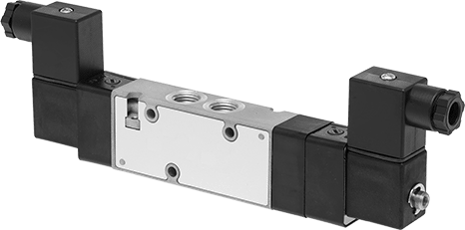

*Purpose:* To send and evacuate air to either chamber of the air cylinder. This is the main component of the auto door.

*Basic Information:* “5 way” means there are 5 ports: 1 supply inlet, 2 outlets (to air cylinder), 2 exhaust ports (metered with exhaust flow control valve). “2 position” means it is always pressurizing and evacuating, (there is no mode where no air flows).

There are two solenoids because this is a double action valve. Once a solenoid is initially powered, the valve will maintain its position even after the solenoid has lost power.

This particular part actually has NPTF threads. If that means nothing to you, then ignore this.

*Operation:* In order to understand its operation consult Figure _. Both diagrams feature the 5W2P valve and an air cylinder. The 5W2P valve seems to have two parts, both with repeating 1,2,3,4 and 5. These two sections do not represent the valve mechanically, they only represent the two positions the valve can be in. So this valve only has 5 ports, not 10. You can see there are two different positions by seeing how the air cylinder’s air lines switch.

The diagram on the left will be called Position 1. In Position 1, air flows in two directions.   
Direction 1: From the supply (1) to the first outlet (2).

Direction 2: From the second outlet (4) to the second exhaust (5).   
 Because air is flowing into the left chamber of the air cylinder and out the right side of the chamber, the piston moves to the right.

The diagram on the right will be called Position 2. The idea is the same and now the piston moves to the left. These two positions are why it is called “2 Position.”

Please note that the T next to 3 in Position 1 and the T next to 5 in Position 2 means the air flow is blocked entirely.

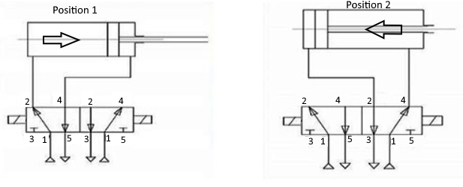

There are two solenoids in the 5W2P valve, (called double action 5W2P valves). Applying 24VDC across the terminals shown in Figure _ activates the solenoid.

| *Power to which solenoid, (label facing viewer)* | *Door open or close?* | *Piston movement* | *Port that sends air to cylinder* | *Port that pulls air from cylinder* | *Port that exhausts* |
| --- | --- | --- | --- | --- | --- |
| Left | Open | Extend | 2 | 4 | 5 |
| Right | Close | Retract | 4 | 2 | 3 |

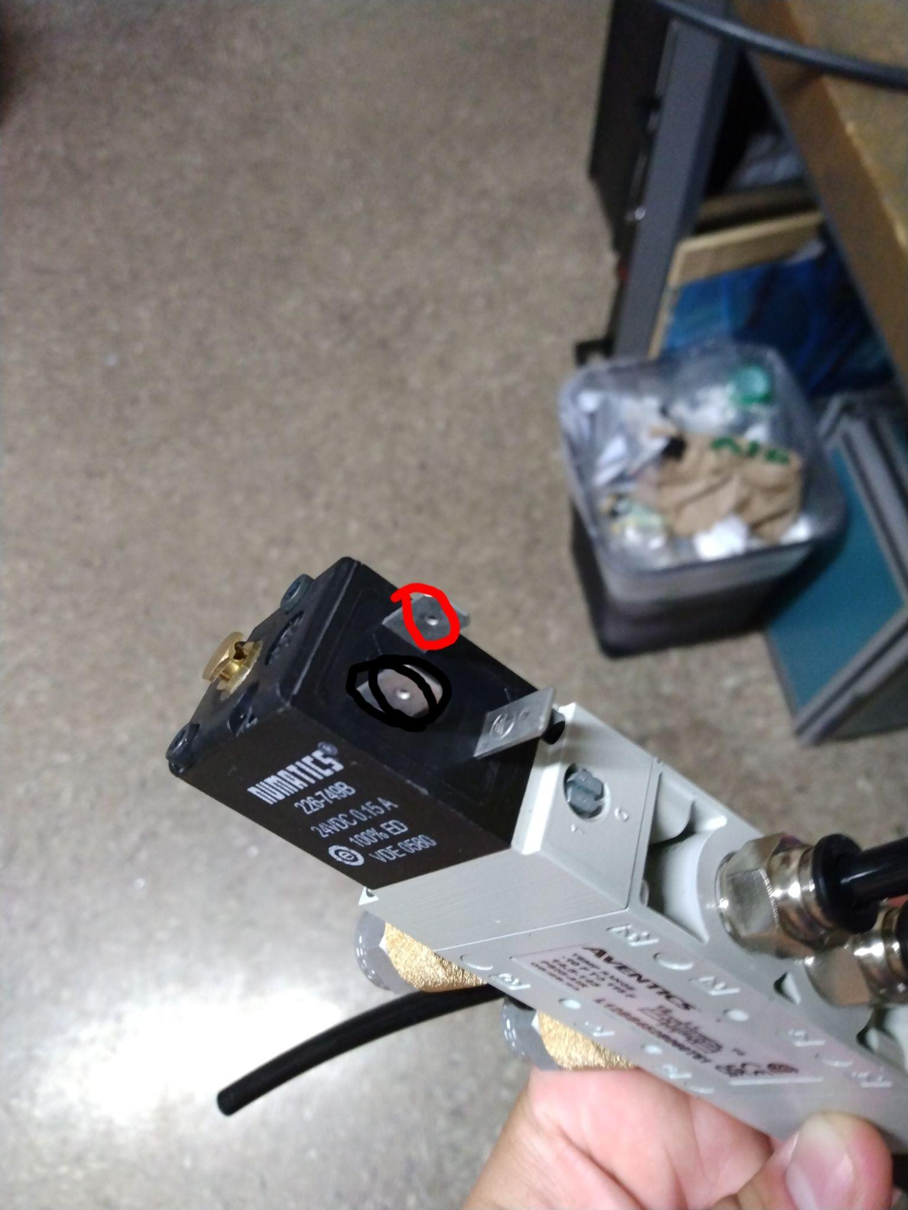

Figure _:

Diverting Valves (Switch Valves):

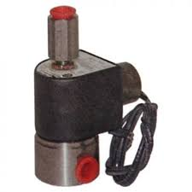

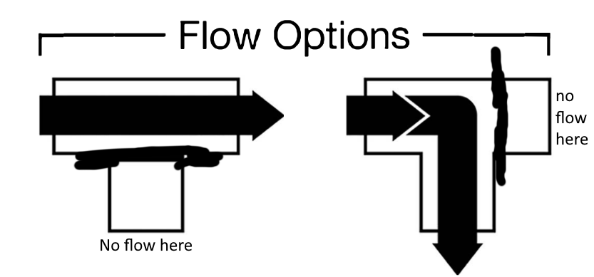

*Purpose:* In this system, two 5W2P valves are connected to the air cylinder: normal 5W2P valve and safety 5W2P valve. The two diverting valves allow the machine to switch between these two 5W2P valves. When one 5W2P is allowed, the other is completely blocked off.

*Basic Information:* Don’t put fingers inside, I dunno?

*Operation:* A diverting valve has three ports, called Port 1, 2, and 3. When the solenoid is unpowered it allows flow between two ports, (in practice Port 2 and Port 3). When powered, it blocks Port 3 and allows airflow only between Port 2 and Port 1. This table summarizes the actual flow pattern for the valves used.

They are controlled by the same terminal that controls the safety 5W2P valve, meaning both diverting valves and the safety 5W2P valve turn on and off at the same time.

| *Power to solenoid?* | *Allows* | *Blocks* |
| --- | --- | --- |
| No | Port 2 and Port 3 | Port 1 |
| Yes | Port 2 and Port 1 | Port 3 |

Supply Valve:

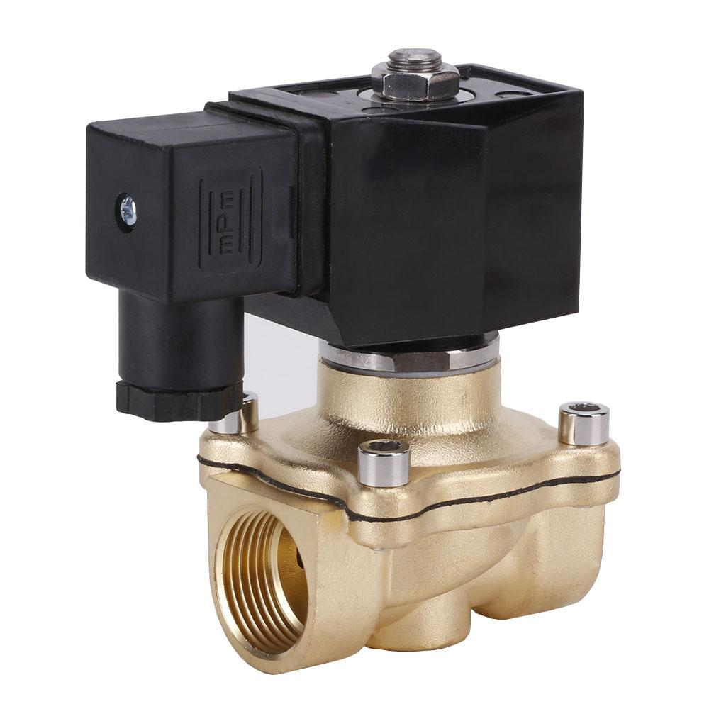

*Purpose:* The purpose is to cut air to the entire system in case of a power outage. This is very important because even though the power cuts out, the excess still in the line does not and the air cylinder can continue to move uncontrollably.

*Basic Information:* The supply valve is an on/off valve. It is a normally closed valve.

*Operation:* No power = no airflow.

| *Powered?* | *Airflow?* |
| --- | --- |
| No | No flow |
| Yes | Flow |

Pressure Regulator:

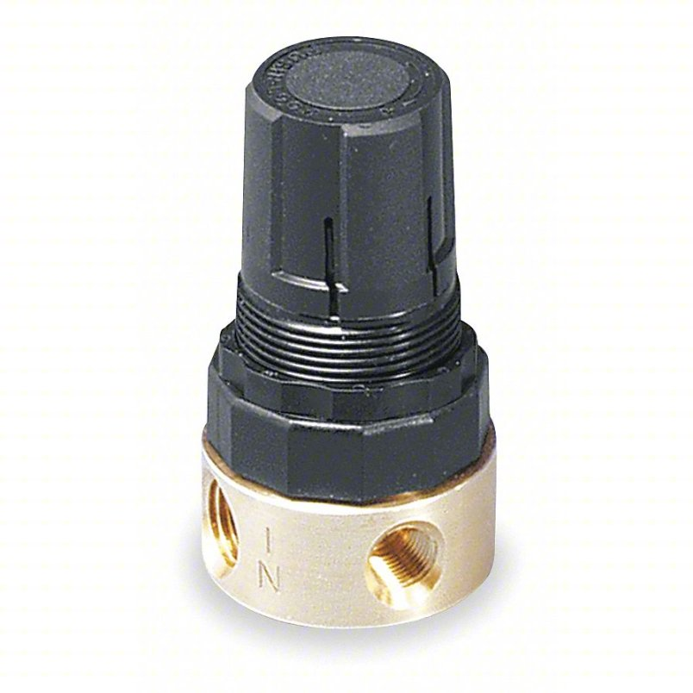

*Purpose:* Change the air pressure dummy

*Basic Information:* None

*Operation:* To adjust the pressure pull up on the black knob and twist. To lock the knob, push down.

Exhaust Flow Control Valve:

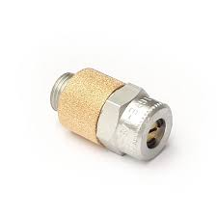

*Purpose:* The exhaust flow control valve controls the speed of the air cylinder by controlling the amount of air emitted from the 5W2P valves.

*Basic Information:* Bolt size is 11/16.

*Operation:* They can be adjusted with a small flathead screwdriver. Keep in mind this is one of two flow control valves that dictate the air cylinder’s speed.

| *Rotation* | *Speed up or slow down?* |
| --- | --- |
| Clockwise | Speed up |
| Counter clockwise | Slow down |

Intake Flow Control Valve:

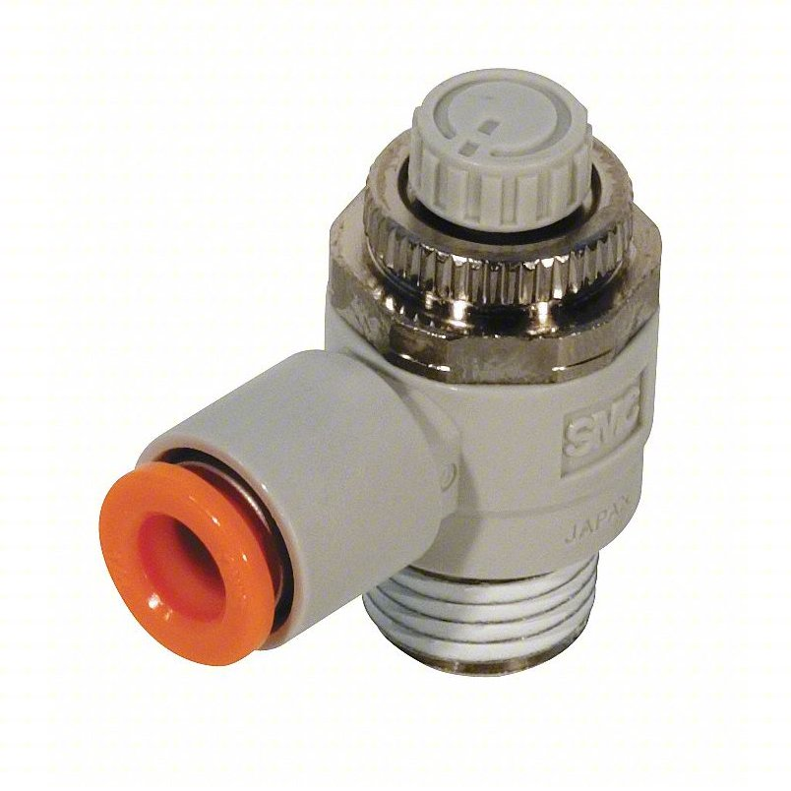

*Purpose:* The intake flow control valves control the speed of the air cylinder by controlling the amount of air that enters the air cylinder.

*Basic Information:* Inlet position can be adjusted independent of tightening/loosening the threads.

*Operation:* The adjustment is the white circle on the top.

| *Rotation* | *Speed up or slow down?* |
| --- | --- |
| Clockwise |  |
| Counter clockwise |  |

Magnetic Proximity Sensor:

*Purpose:* To “tell” the machine when the door is fully open, (when the piston is fully extended), by sending 24V to a relay in the back of the machine.

*Basic Information:* A proximity sensor is an electronic device that can “tell” other machines when a desired object is close to the proximity sensor. In this case, the proximity sensor detects magnets. The overall purpose of the magnetic proximity sensor in this system is to “tell” the machine when the door has is fully open, (when the piston is fully extended).

The magnetic proximity sensor has an orange LED that lights up when a magnet is detected.

*Operation:* The air cylinder has a magnet attached to the back of the piston, (inside the casing so the magnet is not visible from the outside). The magnetic proximity sensor is to be attached to on the air cylinder, positioned next to where the magnet will be when the piston is fully extended.

The magnetic proximity sensor has one side that is sensitive to magnets. If this side is not mounted near the air cylinder the magnetic proximity sensor may not be able to detect the piston magnet. (I can’t remember exactly what side it is but I believe it is the largest side that has no markings on it).

The detection range is very small so the magnetic proximity sensor must be very close to the air cylinder casing.

The magnetic proximity sensor has three wires: brown, black, and blue. Brown is the 24 Volt Wire. Blue is the 0 Volt Wire. The black wire is the output to signal to the machine when the magnetic proximity sensor detects the air cylinder’s magnet. It works like this: when the magnetic proximity sensor does not detect the air cylinder’s magnet, the black wire will produce 0V. When it does detect the air cylinder’s magnet, (aka when the door is fully open), the black wire will produce 24V.

Light Curtain and Safety Relay:

*Purpose:* To open the door if an object is in the door’s way. It controls the safety 5W2P valve and diverting valves.

*Basic Information:* The light curtain has two outputs but neither are compatible with the CNC. These outputs are called OSSD1 and OSSD2. These outputs are self checking; the worry is that the outputs will not be able to switch and the system will not be able to control the auto door. They test this by randomly switching the outputs. They switch for a very small amount of time (100s of microseconds). If they can switch, then everything is okay. If they cannot, then the light curtain detects this and forces the door open. This is the self checking process.

As stated earlier the light curtain’s outputs cannot be directly connected to the CNC. They must be connected to a safety relay. A safety relay takes both of the OSSD outputs, monitors them, and transforms them into one single output that can be read by the CNC. The safety relay also has self checking capabilities, identical to the light curtain’s.

The light curtain has a protective length of 6.3 inches.

*Operation:* The light curtain produces lasers between its two components. When an object gets in the way, both OSSD outputs will drop from 24V to 0V, attaching to the safety relay. The safety relay will then process this and close its output relay. 24V will then be sent to a relay in the back of the machine and will trigger the safety 5W2P valve and diverting valves. Specifically:

1 (Facing with label up), the left solenoid of the safety 5W2P will be actuated and held, (latched).

2 The diverting valves will actuate and be held, (latched), blocking Port 3 and allowing air to flow between Port 2 and Port 1. This will completely cut off the normal 5W2P valve.

3 This will force the door to open, (piston to extend).

4 The ladder code will time out and set an alarm, stopping the machine from operating.

5 When danger is concluded, the operator can press the ALARM RESET EMG. RELEASE button on the keyboard to shut off the safety system, deactivating the safety 5W2P valve, deactivating the diverting valves, (which allows the normal 5W2P to take control again), and normal operation will resume.

6 Keep in mind, the second the object is removed from the light curtain’s laser, the light curtain and safety relay will reset. At this point, only the machine is keeping the door open and the safety system engaged. This is adjustable, (see the [Finishing Up the Lynx 220L](https://docs.google.com/document/u/0/d/1lHe_dQuX5BtElMpw_9GBA3AOfG6Tnj45F4rXxdiytM4/edit) document REF20).

**Maintenance:**

1. Double check metal debris is not resting on the piston. The debris will undoubtedly destroy the seal and render the air cylinder useless.
2. Squeaking usually means friction. Friction means wear. Make sure to lubricate any parts squeaking.
3. Periodically clean the light curtain’s sensors because dirt build up can hinder its ability to detect.
4. Clean debris from the door track.
5. If you want to go above and beyond, usually the manufacturers’ websites will have dedicated maintenance manuals for parts.

**Adjust Door Speed:**

There are multiple ways to adjust the door speed. Try to only adjust the speed using the flow control valves, not the overall system pressure. Remember, more pressure does not necessarily mean more airflow.

1 There are two sets of flow control valves: intake and exhaust. Examine Figure _, the left is the intake and the right is the exhaust.

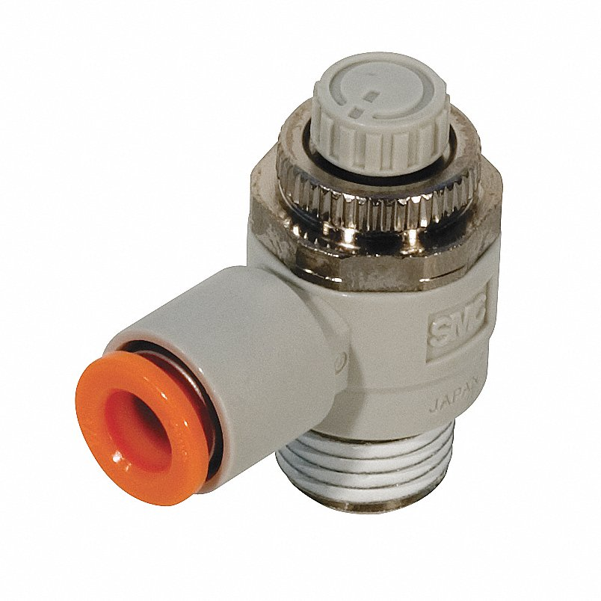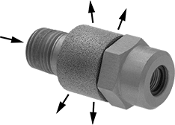

Figure :

The intake flow control valves are mounted directly on top of the air cylinder, there are two of them. The exhaust control valves are mounted to both 5W2P valves, there are four of them. To change speed follow the tables below:

| *Rotation (Exhaust Flow Control Valve)* | *Speed up or slow down?* |
| --- | --- |
| Clockwise | Speed up |
| Counter clockwise | Slow down |

| *Rotation (Intake Flow Control Valve)* | *Speed up or slow down?* |
| --- | --- |
| Clockwise |  |
| Counter clockwise |  |

2 To a certain extent, increasing the pressure will increase the door’s speed. Keep in mind increasing the pressure also increases the force the door will move with; the higher the force, the more wear on everything. Increasing the pressure will also change the behavior of the entire system. Only operate the system in the range of 12PSI to 96PSI, otherwise sluggish or bouncy behavior may occur.

**The Power Cabinet (What Relays Used):**

The power cabinet contains all electrical systems, (with the exception of the computers and circuitboards). This includes the relays used to operate the auto door as well as the 220V equipment. The 24V system will give you a nasty shock but likely will not do serious damage. The 220V system may hospitalize you. All of the 220V equipment is marked with a yellow sticker.

The power cabinet is located at the back of the machine. In the case of the Lynx 220, to access the power cabinet first loosen the two Allen bolts and twist the I/O knob all the way counterclockwise to release the door.

If the Fanuc I is off then the relays will also be off.

1L+ is 24V and 1M is 0V or common (and sometimes ground).

The relays work a little differently than how a stereotypical relay would work. Usually a relay is unpowered and acts only as a switch. The output relays (dictated by TM2) provide their own power so there is no need to wire it to a power terminal (1L+).

Table _ contains the parts and their relays. Keep in mind 1L+ is 24V source, M is ground. (If this table is difficult to understand you may need to look through the electrical manual for the power cabinet schematics as well as the How to Read the Code section on Page .)

| **Part** | **Relay Rack** | **Relay Name** | **Contact Name (for code)** |
| --- | --- | --- | --- |
| Supply Solenoid | XT1105 (TM1) | Any 1L+ and M | None, no code needed |
| Normal 5W2P Valve | XT1104 (TM2) | Y1.1  Y1.2 | DOP.R  DOC.R |
| Safety 5W2P Valve | XT1106 (TM2) | Y4.2 | M92.R |
| Diverting Valves | XT1106 (TM2) | Y4.2 | SDOP.R |
| Light Curtain/Safety Relay | XT1105 (TM1) | X12.4 | EDGE.M |
| Magnetic Proximity Sensor | XT1107 (TM1) | X10.4 | DOC.M (SX231) |

**How to Read the Code (Ladder Code):**

There are simulators online that allow you to write some code and test it. This will aid you greatly in your learning but will also allow you to test your code before writing it to the CNC.

Part 1: Contacts

The CNCs, (the Lynx at least), allow you to watch the code while the machine operates. This can be very handy for troubleshooting. Likely the code itself will not fail, but because you can monitor the code in real time, it can show you which parts are not triggering. This is an alternative to pulling the parts and wires out and testing everything with a multimeter.

Observe Figure _. The symbol on the left represents a normally open contact and the right represents a normally closed contact.

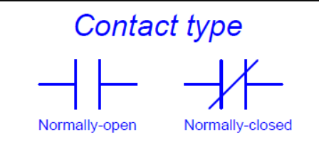

Figure :

The normally closed contact can be remembered because it has a slanted line between the vertical, representing a closed circuit, (a closed circuit will allow electricity to flow while an open circuit will not. Think of a light switch). The normally open contact has no slanted line and represents an open circuit, a circuit where no electricity flows. Here is a concise version:

Normally open = open circuit = no electricity

Normally closed = closed circuit = electricity

This is where it becomes more complicated. Each contact has two states: normal and actuated. Look at Figure _.

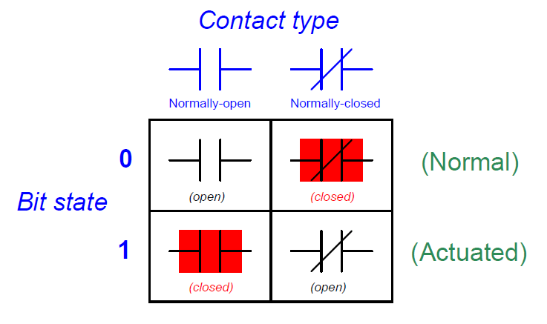

Let us examine the normally open contact first. The normally open contact has no electricity when it is in its normal state. But, just like a light switch, when it is flipped (actuated) it allows electricity to flow through it. The CNCs highlight the contact in color (usually blue but in this diagram it just happens to be red) to show electricity flowing through it.

The normally closed contact is the exact opposite of the normally open. In its normal state electricity is flowing, (shown by the red), and when it is flipped, (actuated), no electricity flows through it.

Okay so what exactly are contacts? This will be explained better in Part 3 but all contacts are just switches. There are three types: input relays, bits, output relays. But at the end of the day they are all just switches.

Part 2.1 Logic:

So what is the point of any of this? By chaining two contacts together we can give the computer “intelligence.” First let us look at AND logic. Look at Figure _. Here we have four circuits. Each one has two switches (treats these as the contacts we learned in Part 1) and one light bulb. Notice that only in the last circuit is the light bulb on. This is also the only circuit where both switches are closed. Let us compare.

In the first circuit, Switch B is ready to turn on the bulb but Switch A is not. In the second circuit, Switch A is now ready but Switch B is not. In the third, circuit neither switch is ready. In all three of these circuits *because both switches are not ready the bulb never comes on*. Even if one switch is ready, the other one has to be as well. This creates AND logic. You need Switch A AND Switch B.

So for example, we want the auto door to open if the chuck is completely stopped AND the coolant is off. This AND logic allows us to give the computer “intelligence.”

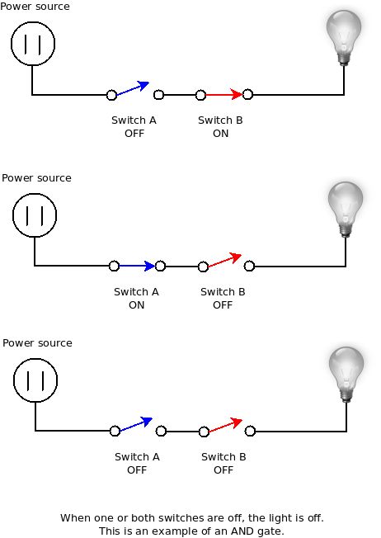

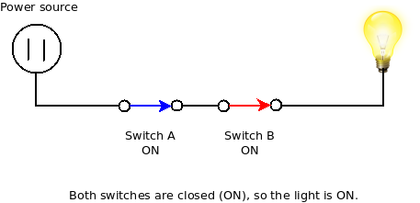

Figure :

Second, let us look at OR logic. Examine Figure _. Here we have four circuits. Each one has two switches (treats these as the contacts we learned in Part 1) and one light bulb. Notice that only in the third circuit is the light bulb off. This is also the only circuit where both switches are open. Let us compare.

In the first circuit, Switch A is not ready but Switch B is; this means the bulb is on. In the second circuit, Switch A is ready but Switch B is not; this means the bulb is on. In the third circuit, neither Switch A nor Switch B are ready; this means the bulb is off. In the fourth circuit, both Switch A and Switch B are ready; this means the bulb is on. In these circuits *only one of the switches need to be ready for the bulb to turn on.* This creates OR logic. Either Switch A or Switch, (or both), B can be ready for the bulb to be on.

So for example, we want the auto door to close if the safety curtain is tripped OR the operator closes it. This OR logic allows us to give the computer “intelligence.”

Part 2.2: Logic in Ladder Code

Take some time and become comfortable with AND and OR logic before moving on.

So how do we apply this to ladder code? The AND logic about the chuck being stopped and Coolant Off is shown in Figure _. A good way to think about ladder code is to think of it like electricity flowing from the left side to the right side. So in this case if both Chuck Stopped and Coolant Off are closed, (actuated), then electricity will flow through them and into the circle labeled Door Open. Figure _ is an example where the coolant is off but the chuck has not stopped and therefore the door is not open. (Remember, the pieces will be colored when electricity flows through it).

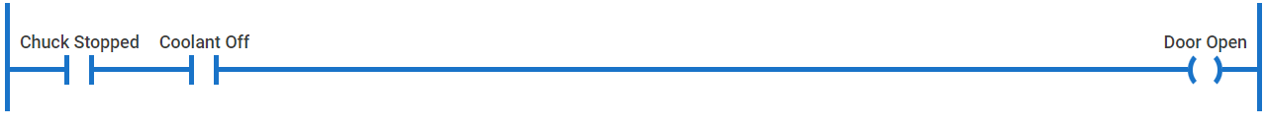

Figure _:



Figure _:

What is the circle? The circle represents a physical relay on the CNC, (an output relay). So in the ladder code we are “sending electricity from the left side to the right side,” that is basically what we are doing in real life as well. In this case, (but not always), Chuck Stopped and Coolant Off are relays too, input relays. In real life, they would likely be plugged into a sensor. So, yet again, electricity is flowing from the sensors “through the code” and into the output relay Door Open.

As a side note, you may be wondering why normally open contacts were chosen for the Chuck Stopped and Coolant Off. It is based on the sensor type. Sensors can either supply 24V when triggered, (they will be called Electricity When Triggered), or can drop to 0V when triggered, (they will be called No Electricity When Triggered). Why would that even exist?

The Electricity When Triggered Sensor is “normal.” When nothing is happening, then there is no voltage. This is intuitive to people because it is essentially saying, “When nothing is happening, voltage off. When something is happening, voltage on.”

The No Electricity When Triggered Sensor is used in safety for power outages. This is how a light curtain works. When everything is fine it produces 24V. When someone puts their hand in the way, it drops to 0V. If the power goes out, well, the voltage goes to 0V and the safety state is triggered.

This all seems unnecessarily complicated but it actually can simplify things. What if

Also, Electricity When Triggered = normally open. No Electricity When Triggered = normally closed. Pretty much everything in ladder code is just understanding normally closed and normally open.

Part 2.3 Combining OR and AND logic

Okay so now let us combine AND and OR logic. Look at Figure _. As we can see we have our familiar AND logic with Chuck Stopped and Coolant Off. But now we have a different branch, (they are actually called rungs), that has the Master Override contact in it. If we again think of electricity flowing from the left to the right we can see that if Master Override is triggered, then so is Door Open *even if Chuck Stopped and/or Coolant Off is not*. This is our OR logic.

So AND logic is represented by two or more contacts in series. OR logic is represented by two or more contacts in parallel.

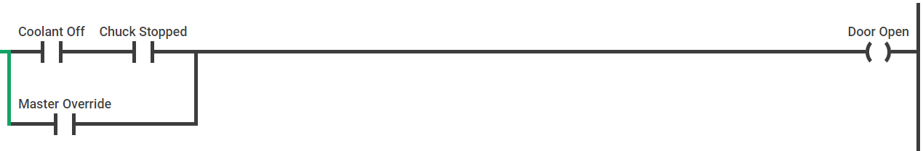

Figure :

Part 2.4 How the Computer Reads Ladder Code:

How does the computer know what to read and when? The computer will read the code left to right, up to down. In this case Chuck Stopped will always be read first because it is the most left on the top rung. Then Coolant Off will be read. Then it would look at Door Open and see if it has electricity to it. Next Master Override will be read and, again, it would look at Door Open to see if there is electricity to it. Then the computer would skip to the next rung dealing with some other part of the machine. The computer will read the code similarly to how you would read a book, start at the top, read left to right.

To be more specific, the computer does three scans:

1 Check the state of the inputs, on or off

2 Check to see if any of them have changed

3 Change the outputs accordingly

The computer will read all of this code very, very quickly, (usually within a couple hundred microseconds). This causes a problem. If you wanted to hit the Master Override button, by the time it took you to press and release the button, the computer has read the code probably 10 times. Honestly it is kind of a questionable design and it stumped me for a while. This is why latching becomes important; latching will be covered in Part 2.5.

One final note. We have already discussed input and output relays but there is a third type of contact: bits. Bits are also switches but they are internal to the computer, (they are transistors). Bits have no way to interact with the “real” world, aka, they are not input or output relays. Bits can be used in lots of different ways; the good news is that most of these ways revolve around the same idea: to make connections between relays without having to directly wire them together. An example is given in Figure _.



Figure _:

Let us say ARST is a contact for the reset button that is actually on the machine’s keyboard, (technically ARST is not but for this example let us just say that). INRST is a bit and is designed to be a reset system for the door specifically. We can see this because DOP.R is used with it.

Even though INRST and ARST are essentially doing the same thing, INRST is an “upgraded” version of ARST; it includes more about the door. By using bits we can either enhance the ability of a button/relay or design a button/relay specifically for a situation. None of this is very clear unfortunately but it comes with practice.

One final note about bits. How do we know when a contact is a bit? When you select a contact, (in edit mode), it will give you the technical name of the contact. If it has a X in front of it (like X13.7) then it is an input relay. If it has a Y in front of it (Y3.3) then it is an output relay. If it has neither then it is a bit.

Part 2.5 Latching:

Let us start with a problem first. Let us say we want to install a light inside the chamber that is controlled by a button on the machine. We want the light to stay on after we pressed the button; with our understanding of ladder code right now that would not be possible. The second the operator releases the button, the contact would be released as well and the light would turn off. So how do we keep the light on?

We achieve this by latching. Latching is exactly what it sounds like; it latches the contact either open or closed. Observe Figure _ and Figure _ which is our first attempt at latching.

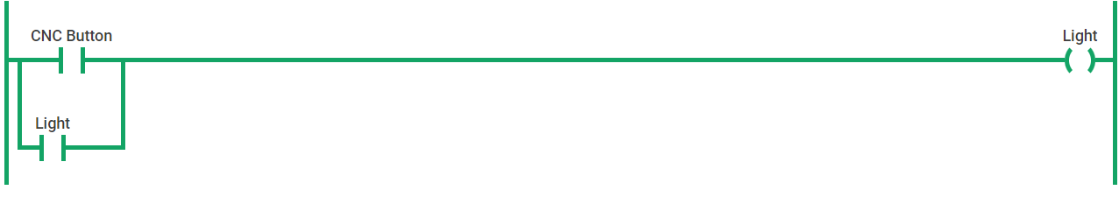

Figure _:

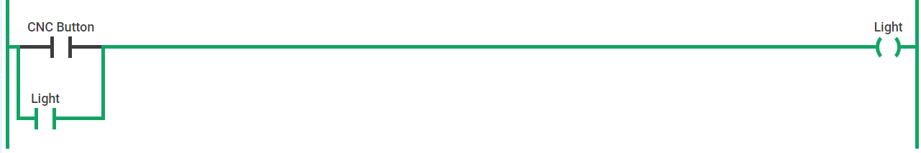

Figure _:

Notice how Light is an input and an output. This may seem strange at first but remember the goal; if Light is on we want it to stay on. As seen in Figure _ and Figure _, no matter if CNC Button is on or off, Light stays on.

Great, so the light inside the machine stays on and we are done? No. How do we turn off the light?

We need to add a reset contact, one that is normally closed. Observe Figure _.

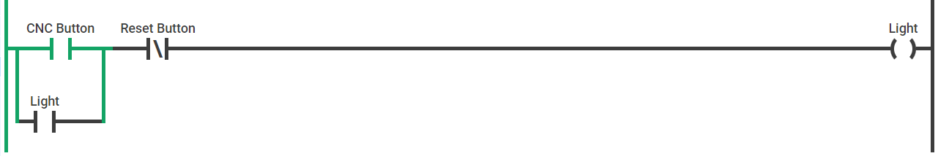

Figure _:

Now the operator is able to turn off the light by using the Reset Button. (Performing the simulation of this makes it much clearer). Obviously having two separate buttons, (Light Button and Reset Button), to operate one light is kind of inconvenient. But this is just to demonstrate the idea of latching. The actual code for latching and unlatching for a single button, (called toggling), is more complicated and can be found online by searching “how to toggle in ladder code.”

Part 3 The Actual Code:

This is going to be kind of a jump in difficulty but we needed to discuss the actual code eventually. Look at Figure _, which is the actual code used in the CNC. (The states of the contacts in Figure _ are not relevant to what is written here. Pay attention only to the structure and order of the contacts, not which ones happen to be actuated in this photo).

All of these rungs lead to a contact named DOP.R which is an output relay to open the door. (In terms of our actual system, this relay will actuate and electricity will then flow to the normal 5W2P valve). We know it is a relay because it has .R in its name. We can also look at the electrical manual to see all of the inputs and outputs.

Look at the second rung. The first contact is M52, and since this is a M-Code command, it is a bit contact, (has no real relay). The second contact is DOC.M which is an input relay, (from the manual). DOC.M connects to the magnetic proximity sensor that “tells” the CNC when the auto door is finally open. Finally we have SSTA which is a bit contact as well which tells us if the chuck has stopped spinning. (You may think this is an input because it comes from some sensor measuring the chuck speed right? Well, yes, but this sensor input is processed through a circuitboard and then the computer sends the signal internally. This does not have to be the case but that is the way the engineers made it. It could have easily been a sensor that plugs into the input relays instead of a circuitboard. Confusing I know.)

All three of these have been ANDed with each other. Remember that the contacts in blue means electricity is flowing through them. So we need three things to happen before the door opens:

1 M52 is normally open which means it needs to be actuated for electricity to flow through it. This is achieved by writing M52 in the M-Code.

2 DOC.M is normally closed which means we do not want it to be actuated for electricity to flow.

3 SSTA is normally open which means it needs to be actuated for electricity to flow through it. In this case the chuck stops and the circuitboard triggers the contact.

But there is actually one more contact we have to consider even though it is not unique to this rung: TMB129. This is a special contact called a timer. It behaves exactly like a timer. In this case when it is triggered it counts up, causing a delay. We want this delay because we want the door’s interlock to release before the air cylinder tries to open the door.

Let us examine the last rung with a contact called CLINT. CLINT stands for CLose door INTerrupt. This is our safety system. Notice how it is not ANDed with anything at all. Why? Because we always want the safety system to take control.

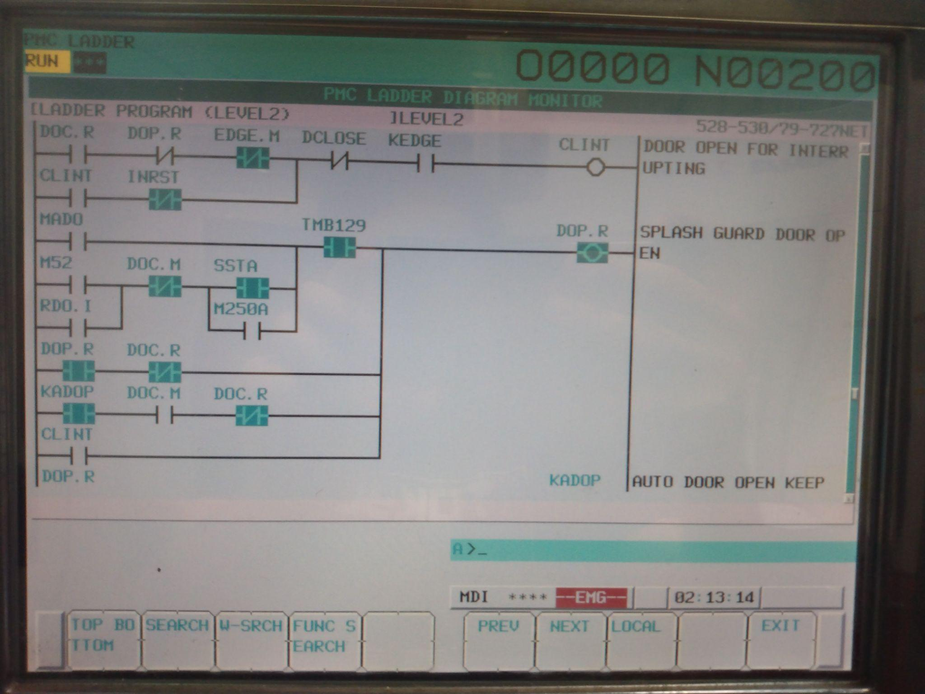

Figure :

Troubleshooting:

BE SURE THAT NO ONE IS NEAR THE DOOR NOR ELECTRICAL SYSTEM WHEN TROUBLESHOOTING. YOUR ACTIONS COULD CAUSE THE DOOR TO MOVE WITHOUT POSSIBILITY OF BEING STOPPED. TURN OFF THE AIR SUPPLY IF IT IS NOT NECESSARY FOR THE TROUBLESHOOTING AND EVACUATE BOTH CHAMBERS OF THE AIR CYLINDER BY DISCONNECTING THE LINES TO IT, STARTING WITH THE HOSE AT THE BACK OF THE CYLINDER.

**Try the Quick System Check First**:

**Door Does Not Open:**

1 Is the safety system on?

1. Press the MESSAGE button on the keyboard. Does it say “NO. 2040 SPLASH GUARD, DOOR OPENED / OPERATOR’S DOOR OPENED”? Press the ALARM RESET EMG. RELEASE button on the keyboard to fix it.

2 Check the fuses for the 5W2P valves.

1. Power down the machine and turn off the circuit breaker. Wait 20-30 minutes.
2. Find the normal 5W2P valve. The fuse holder should be attached to the red wire.
3. Remove the top of the fuse holder and pull the fuse out
4. Grab a multimeter and find the continuity setting. First, touch the red connector and the black connector together to test the buzzer inside the multimeter; if it beeps then you are good, if not then you need to replace the multimeter. Next, place the red connector on one leg of the fuse and the black connector on the other leg of the fuse. If you hear the multimeter beep, then the fuse is good. If it is silent, the fuse is blown and needs to be replaced. It is a 2 amp automotive fuse you can grab from O'Reillys or Autozone.
5. Once the new fuse is obtained place it firmly into the fuse holder, (it does not matter which way you insert it), snap the lid back on firmly, and power the CNC back on, TAKING CARE TO MAKE SURE NO ONE OR NOTHING IS IN THE DOOR’S WAY.

2 Test the normal 5W2P valve’s solenoids with the 24V Tester.

*Tools Needed:*

*24V Tester  
 Extension Cord*

*Alligator Clips (Optional)*

*Multimeter*

1. Power down the machine and turn off the circuit breaker. Wait 20-30 minutes.
2. While waiting, set up the extension cord and 24V Tester. We will test the 24V Tester to make sure it is working. Separate the red and black wires. Set the multimeter setting to 200V. Connector the red lead of the multimeter to the red wire of the 24V Tester. Do the same with the black wires. Plug in the 24V Tester. The multimeter should read about 24V, (1 or 2 volts over or under is okay, you’re looking for something far from 24V). (Also -24V is okay as well).
3. Find the normal 5W2P valve. With the label visible, remove the screw on the top of the left DIN connector with a flathead screwdriver.
4. Remove the DIN connector placing it somewhere with no metal.
5. Connect the red and black wires of the 24V Tester as shown in Figure _.
6. Double check the wires are not touching each other before plugging the 24V Tester into the extension cord. Hold the solenoid with a hand. Plug the 24V Tester in. A click should be heard/felt.



A) It might be loose connections on the solenoid’s leads. Turn off the CNC and remove any power source to it, (flip off the breaker labeled Lynx). Wait the recommended time for the internal circuitry to discharge, (found in the CNC machine’s maintenance manual). Inspect the connections to see if they are loose, burn, or stripped(lots of the strands of copper wire are missing).

B) The wires themselves might be damaged. Turn off the CNC and remove any power source to it, (likely just the plug in the wall). Wait the recommended time for the internal circuitry to discharge, (found in the CNC machine’s maintenance manual). Turn on the multimeter and find the continuity setting. First, touch the red connector and the black connector together to test the buzzer inside the multimeter; if it beeps then you are good, if not then you need to replace the multimeter. Place one connector at one end of the wire and the other connector at the other end. If the multimeter beeps then the wire is not broken, if no beeping then replace the wire.

**Door does not close:**

1 Check the fuses for the 5W2P valves.

First power down the CNC and lock it out if you feel the need. If the door does not open during normal operation, check the fuses on the normal 5W2P valve. If the door does not open during safety state, check the fuses on the safety 5W2P valve. The fuses have a container in which you can remove the top. If the fuse is blown you can usually just see that it is disconnected. If you want to be extra sure, grab a multimeter and find the continuity setting. First, touch the red connector and the black connector together to test the buzzer inside the multimeter; if it beeps then you are good, if not then you need to replace the multimeter. Next, place the red connector on one leg of the fuse and the black connector on the other leg of the fuse. If you hear the multimeter beep, then the fuse is good. If it is silent, the fuse is blown and needs to be replaced. It is a 2 amp automotive fuse you can grab from O'Reilly’s or Autozone.

Once the new fuse is obtained place it firmly into the fuse holder, (it does not matter which way you insert it), snap the lid back on, and power the CNC back on, TAKING CARE TO MAKE SURE NO ONE OR NOTHING IS IN THE DOOR’S WAY.

2 Test the normal 5W2P valve’s solenoids with a multimeter.

Figure _ shows which side closes the door. Start with removing the DIN connector, (the submarine scope looking piece), by removing the screw on the top. THERE ARE LIVE CONNECTIONS UNDERNEATH THE DIN CONNECTOR SO BE CAREFUL. Slide the DIN connector far enough off the metal leads until you see three prongs. Switch your multimeter to voltage (in V, not mV), and place the red connector and black connector as shown in Figure _. It should read about 24V (1 or 2 volts over or under is okay, you’re looking for something far from 24V). It can either be positive or negative 24V, it does not matter in this case.



If you are not receiving any voltage:

A) It might be loose connections on the solenoid’s leads. Turn off the CNC and remove any power source to it, (likely just the plug in the wall). Wait the recommended time for the internal circuitry to discharge, (found in the CNC machine’s maintenance manual). Inspect the connections to see if they are loose, burn, or stripped(lots of the strands of copper wire are missing).

B) The wires themselves might be damaged. Turn off the CNC and remove any power source to it, (likely just the plug in the wall). Wait the recommended time for the internal circuitry to discharge, (found in the CNC machine’s maintenance manual). Turn the multimeter and find the continuity setting. First, touch the red connector and the black connector together to test the buzzer inside the multimeter; if it beeps then you are good, if not then you need to replace the multimeter. Place one connector at one end of the wire and the other connector at the other end. If the multimeter beeps then the wire is not broken, if no beeping then replace the wire.

C) Possibly the 5W2P valve’s solenoid is damaged. Turn off the CNC and remove any power source to it, (likely just the plug in the wall). Wait the recommended time for the internal circuitry to discharge, (found in the CNC machine’s maintenance manual). Turn off the main air supply. Remove the the wires from the solenoid leads and find a 24V power source, (like one you plug into a wall for example), and connect the red and black wire to the leads shown above in Figure _. You should hear a somewhat quiet click. If not, the solenoid is definitely broken. If you do, this does not necessarily mean everything is okay.

3 The magnetic proximity sensor

that tells the CNC when the door is fully open is not working or has been wiggled out of its operating distance. This will need to be tested with the power on. Be careful to not touch the metal parts of the wires.

A) First make sure the proximity sensor has not strayed from its mounting place. The proximity sensor is triggered when a magnet is near. This triggering is shown by a orangeish LED lighting up. The magnet on the air cylinder is right in front of the rear black endcap, (the magnet is connected to the back of the piston inside the casing so you will not be able to see it). Make sure the proximity sensor is mounted so that the orangish LED stays on.

B) If the proximity sensor does recognize the magnet, then test the output of the proximity sensor. The proximity sensor has three wires: brown, blue, and black. The brown wire is for 24V. The blue wire is for 0V, (or ground). Grab a multimeter and switch it to the V setting, (not mV). Place the red connector to the brown wire and the black connector to the blue wire. We want the multimeter to read 24V (1 or 2 volts above or below 24V is okay, you are looking for way less or more than 24V). If it is not receiving 24V then there is a loose connection or the wire is damaged. Turn off the CNC and remove any power source to it, (likely just the plug in the wall). Wait the recommended time for the internal circuitry to discharge, (found in the CNC machine’s maintenance manual). Turn the multimeter and find the continuity setting. First, touch the red connector and the black connector together to test the buzzer inside the multimeter; if it beeps then you are good, if not then you need to replace the multimeter. Place one connector at one end of the wire and the other connector at the other end. If the multimeter beeps then the wire is not broken, if no beeping then replace the wire.

Next, leave the black connector attached to the blue wire. Place the red connector on the black wire, (black wire of the sensor not the multimeter), When the proximity sensor is not near a magnet, (when the orangish LED is not on), this should read 0V. Bring the proximity sensor near enough to a magnet so that the orangeish LED comes on. The multimeter should read about 24V (1 or 2 volts above or below 24V is okay, you are looking for way less or more than 24V). If the voltage reading is not 0V away from the magnet and not 24V near the magnet then the sensor needs to be replaced.

**Noisey Parts:**

If the pneumatic parts start clacking or clanking it is usually due to abrupt or inconsistent airflow. Abrupt airflow can be fixed by:

1 Checking if any of the valves are damaged through visual inspection or disassembly

2 Adjusting operating pressure via regulator

3 Something in the system has changed and may require a soft start valve. This would be placed at the beginning of the pneumatic system, likely after the supply solenoid valve.

Inconsistent airflow can be fixed by:

1 Check that each valve can be fully actuated and is not blocked by debris.

2 Check for damaged valves

If the valves emit a rapid clicking it means the solenoid is not receiving enough electrical power to remain on. This should be stopped immediately as it damages the part. This can be fixed by:

1 Ensuring the part is receiving the power it needs. To do this, measure the voltage and current with a multimeter, multiply the two numbers, and see if it is close to the watts given on the part’s sticker.

2 Inspect the solenoid for any damage or debris.

**Light Curtain Does Not Open Door:**

If the door is closed and the door interlock system is engaged, the light curtain cannot open the door. (It will still react to objects breaking the lasers’ paths though).

**Door Time Out Alarm Message:**

Quick System Check:

The following is a quick way to test all the components. This would be a good procedure to use every couple weeks to every month. It also can serve as a quick way to troubleshoot the system.

1. Grab another operator who knows how to use MDI
2. One person will place their hand on the valves to test, (call them Outputter), and one will enter code from the keyboard, (Inputter).
3. Outputter: Locate the normal 5W2P valve. With the valve orientated so the label is visible, place hand on on the left solenoid

Inputter: Open the door with M52; in MDI

Outputter: A click should be felt/heard

1. Outputter: Stay with the normal 5W2P, place hand on right solenoid

Inputter: Close the door with M53; in MDI

Outputter: A click should be felt/heard

1. Outputter: Find the safety 5W2P, (one set of wire from the DIN connector), as well as the diverting valves. With the valve oriented so the label is visible, place one hand on the left solenoid. Place the other hand on both diverting valves.

Inputter: Ensure the door is fully open. Trigger the light curtain by inserting an object, (not an arm or hand), into the path of the light curtain.

Outputter: A click should be felt/heard

Inputter: Press ALARM RESET EMG. RELEASE button on the keyboard

Outputter: A click should be felt/heard

1. If part e is inconclusive, do the following:

Inputter: Be sure the safety system is triggered by observing that the splash guard door alarm is set by pressing the Message button on the keyboard. (Additional check: attempt to close the door with M53;. If it does not close and the alarm is still on, continue. If it closes will the alarm is still on, there is a bigger problem)

Outputter: Locate the pressure regulator. Turn down the pressure to 20PSI or lower. Return to the normal 5W2P valve. Disconnect air hoses from Port 2 and Port 4, (air should be emitted that is okay). Locate the air cylinder. Disconnect air hoses from both ports. If air is emitting from these hoses then the safety system is not functioning. DO NOT OPERATE THE MACHINE. If there is no air then continue to Part g.

1. Outputter: Locate the supply valve. Place one hand on the solenoid.

Inputter: Turn off the computer, (but not necessarily all the power).

Outputter: A click should be felt/heard

Inputter: Turn the computer back on

Outputter: A click should be felt/heard

1. (Do not stress about messing up the ladder code. It is a very specific and multistep process to modify the ladder code. That being said, if you ever see a button that is named EDIT, stop immediately and refer to the Someone Left Edit Mode On section).

h.1) Close the auto door using the M53; with MDI  
h.2) Press the SYSTEM button on the keyboard, top right

h.3) Press the right arrow button right below the screen until PMC LADDER appears on the screen

h.4) Press the blank button right under where it says PMC LADDER

h.5) Press the blank button under LADDER

h.6) Press the blank button under (OPRT)

h.7) Press the blank button under SEARCH MENU

h.8) Type in DOC.M

h.9) Press the blank button under SEARCH

h.10) Press the blank button under NEXT until the layout shown in Figure _ is found.

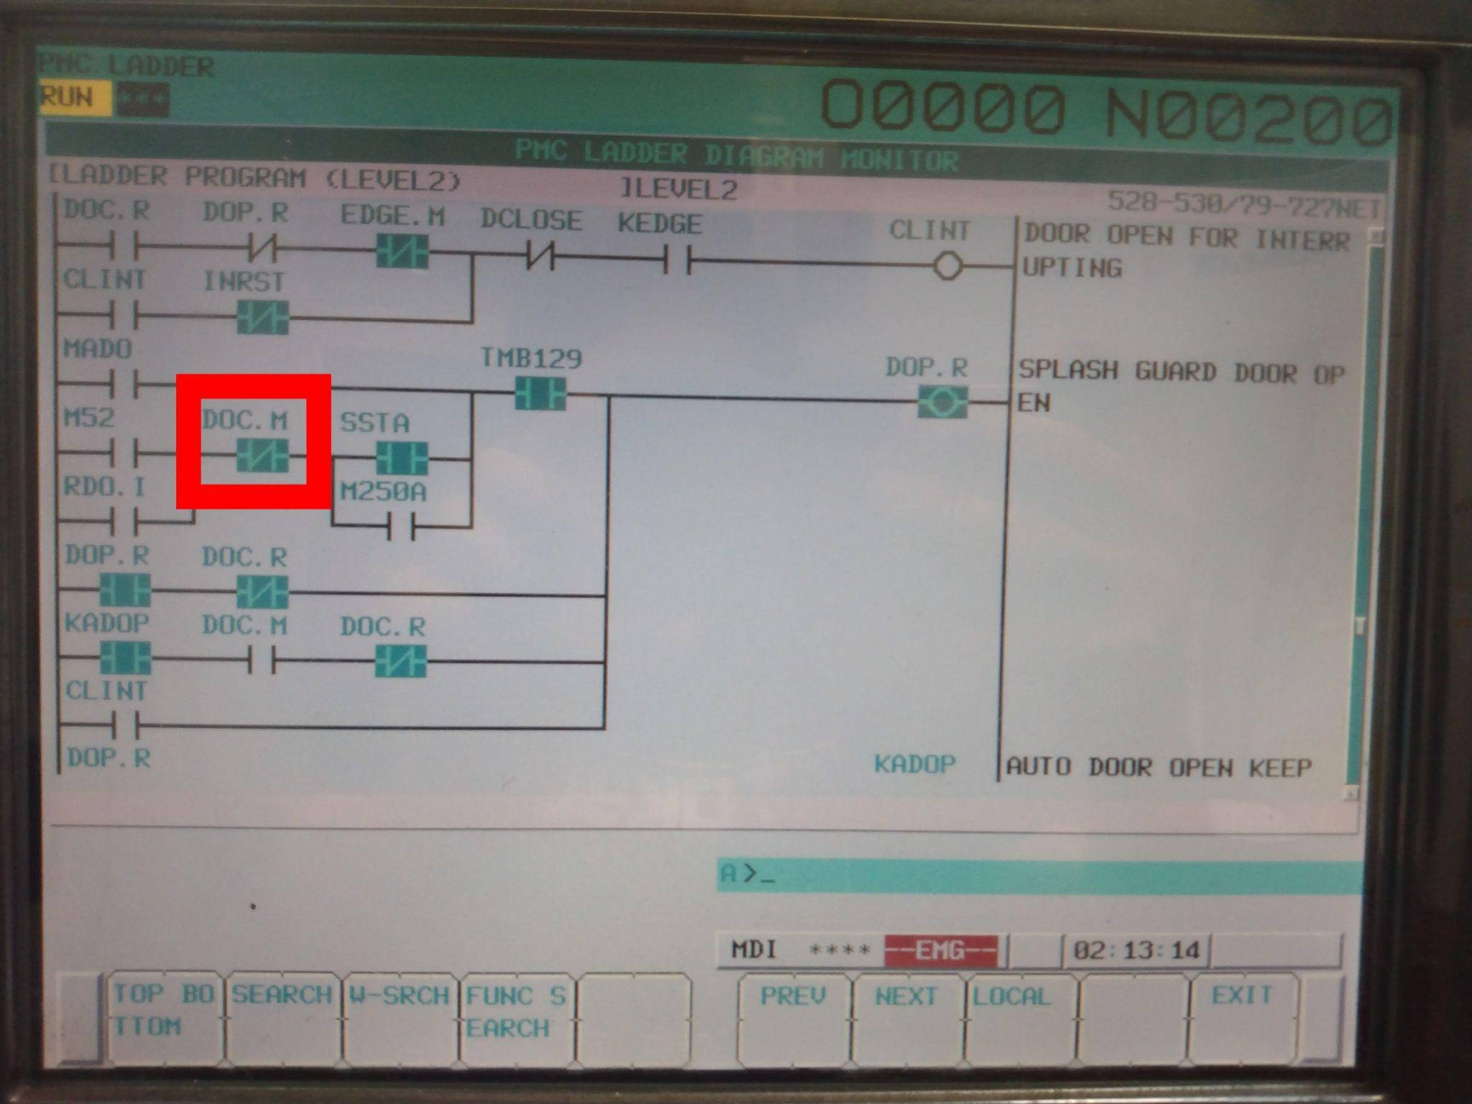

Figure _:

h.11) DOC.M, (focus on the one highlighted in the red box in Figure _), should be colored blue.

h.12) Press the PROG button

h.13) Open the door by typing in M52; in MDI

h.14) Press the SYSTEM button on the keyboard, top right

h.15) Press the right arrow button right below the screen until PMC LADDER appears on the screen

h.16) Press the blank button right under where it says PMC LADDER

h.17) Press the blank button under LADDER

h.18) Press the blank button under (OPRT)

h.19) Press the blank button under SEARCH MENU

h.20) Type in DOC.M

h.21) Press the blank button under SEARCH

h.22) Press the blank button under NEXT until the layout shown in Figure _ is found.

h.23) DOC.M should no longer be blue

1. Two notes before Step i is executed.  
   Note 1: This is Lynx 220L specific; if following this process with another machine, be aware that some steps may be different.

Note 2: Step i requires opening the power cabinet while the power is on. Be careful to not touch ANYTHING other than the power cabinet doors, the power switch, and the release lever for the power switch

i.1) Turn off the Lynx 220L

i.2) Open the power cabinet doors

i.3) Hold the power switch release lever still and rotate the knob to the on position

i.4) Have a second person turn on the computer

i.5) The safety relay should have three green LEDs on.